1. **Find the most common positions played by top-performing players.**

|  |  |  |  |  |  |  |  |  |  |  |  |  |  |
| --- | --- | --- | --- | --- | --- | --- | --- | --- | --- | --- | --- | --- | --- |
| 1 | 2 | 3 | 4 | 5 | 6 | 7 | 8 | 9 | 10 | 11 | 12 | 13 |  |
| GK | CAM | CB | CDM | CF | CM | LAM | LB | LCB | LCM | LDM | LF | LM |  |
|  |  |  |  |  |  |  |  |  |  |  |  |  |  |
| 14 | 15 | 16 | 17 | 18 | 19 | 20 | 21 | 22 | 23 | 24 | 25 | 26 | 27 |
| LS | LW | LWB | RAM | RB | RCB | RCM | RDM | RF | RM | RS | RW | RWB | ST |

* + - Setting up Preferred positions’ Score for each individual position:

**Preferred Position 1 Score**

=IF(BY2="GK",INDEX(AX2:BX2,1,1),

IF(BY2="CAM",INDEX(AX2:BX2,1,2),

IF(BY2="CB",INDEX(AX2:BX2,1,3),

IF(BY2="CDM",INDEX(AX2:BX2,1,4),

IF(BY2="CF",INDEX(AX2:BX2,1,5),

IF(BY2="CM",INDEX(AX2:BX2,1,6),

IF(BY2="LAM",INDEX(AX2:BX2,1,7),

IF(BY2="LB",INDEX(AX2:BX2,1,8),

IF(BY2="LCB",INDEX(AX2:BX2,1,9),

IF(BY2="LCM",INDEX(AX2:BX2,1,10),

IF(BY2="LDM",INDEX(AX2:BX2,1,11),

IF(BY2="LF",INDEX(AX2:BX2,1,12),

IF(BY2="LM",INDEX(AX2:BX2,1,13),

IF(BY2="LS",INDEX(AX2:BX2,1,14),

IF(BY2="LW",INDEX(AX2:BX2,1,15),

IF(BY2="LWB",INDEX(AX2:BX2,1,16),

IF(BY2="RAM",INDEX(AX2:BX2,1,17),

IF(BY2="RB",INDEX(AX2:BX2,1,18),

IF(BY2="RCB",INDEX(AX2:BX2,1,19),

IF(BY2="RCM",INDEX(AX2:BX2,1,20),

IF(BY2="RDM",INDEX(AX2:BX2,1,21),

IF(BY2="RF",INDEX(AX2:BX2,1,22),

IF(BY2="RM",INDEX(AX2:BX2,1,23),

IF(BY2="RS",INDEX(AX2:BX2,1,24),

IF(BY2="RW",INDEX(AX2:BX2,1,25),

IF(BY2="RWB",INDEX(AX2:BX2,1,26),

IF(BY2="ST",INDEX(AX2:BX2,1,27),""))))))))))))))))))))))))))

**Preferred position 2 Score:**

=IF(BZ2="GK",INDEX(AX2:BX2,1,1),

IF(BZ2="CAM",INDEX(AX2:BX2,1,2),

IF(BZ2="CB",INDEX(AX2:BX2,1,3),

IF(BZ2="CDM",INDEX(AX2:BX2,1,4),

IF(BZ2="CF",INDEX(AX2:BX2,1,5),

IF(BZ2="CM",INDEX(AX2:BX2,1,6),

IF(BZ2="LAM",INDEX(AX2:BX2,1,7),

IF(BZ2="LB",INDEX(AX2:BX2,1,8),

IF(BZ2="LCB",INDEX(AX2:BX2,1,9),

IF(BZ2="LCM",INDEX(AX2:BX2,1,10),

IF(BZ2="LDM",INDEX(AX2:BX2,1,11),

IF(BZ2="LF",INDEX(AX2:BX2,1,12),

IF(BZ2="LM",INDEX(AX2:BX2,1,13),

IF(BZ2="LS",INDEX(AX2:BX2,1,14),

IF(BZ2="LW",INDEX(AX2:BX2,1,15),

IF(BZ2="LWB",INDEX(AX2:BX2,1,16),

IF(BZ2="RAM",INDEX(AX2:BX2,1,17),

IF(BZ2="RB",INDEX(AX2:BX2,1,18),

IF(BZ2="RCB",INDEX(AX2:BX2,1,19),

IF(BZ2="RCM",INDEX(AX2:BX2,1,20),

IF(BZ2="RDM",INDEX(AX2:BX2,1,21),

IF(BZ2="RF",INDEX(AX2:BX2,1,22),

IF(BZ2="RM",INDEX(AX2:BX2,1,23),

IF(BZ2="RS",INDEX(AX2:BX2,1,24),

IF(BZ2="RW",INDEX(AX2:BX2,1,25),

IF(BZ2="RWB",INDEX(AX2:BX2,1,26),

IF(BZ2="ST",INDEX(AX2:BX2,1,27),""))))))))))))))))))))))))))

**Preferred position 3 Score:**

=IF(CA2="GK",INDEX(AX2:BX2,1,1),

IF(CA2="CAM",INDEX(AX2:BX2,1,2),

IF(CA2="CB",INDEX(AX2:BX2,1,3),

IF(CA2="CDM",INDEX(AX2:BX2,1,4),

IF(CA2="CF",INDEX(AX2:BX2,1,5),

IF(CA2="CM",INDEX(AX2:BX2,1,6),

IF(CA2="LAM",INDEX(AX2:BX2,1,7),

IF(CA2="LB",INDEX(AX2:BX2,1,8),

IF(CA2="LCB",INDEX(AX2:BX2,1,9),

IF(CA2="LCM",INDEX(AX2:BX2,1,10),

IF(CA2="LDM",INDEX(AX2:BX2,1,11),

IF(CA2="LF",INDEX(AX2:BX2,1,12),

IF(CA2="LM",INDEX(AX2:BX2,1,13),

IF(CA2="LS",INDEX(AX2:BX2,1,14),

IF(CA2="LW",INDEX(AX2:BX2,1,15),

IF(CA2="LWB",INDEX(AX2:BX2,1,16),

IF(CA2="RAM",INDEX(AX2:BX2,1,17),

IF(CA2="RB",INDEX(AX2:BX2,1,18),

IF(CA2="RCB",INDEX(AX2:BX2,1,19),

IF(CA2="RCM",INDEX(AX2:BX2,1,20),

IF(CA2="RDM",INDEX(AX2:BX2,1,21),

IF(CA2="RF",INDEX(AX2:BX2,1,22),

IF(CA2="RM",INDEX(AX2:BX2,1,23),

IF(CA2="RS",INDEX(AX2:BX2,1,24),

IF(CA2="RW",INDEX(AX2:BX2,1,25),

IF(CA2="RWB",INDEX(AX2:BX2,1,26),

IF(CA2="ST",INDEX(AX2:BX2,1,27),""))))))))))))))))))))))))))

**Preferred position 4 Score:**

=IF(CB2="GK",INDEX(AX2:BX2,1,1),

IF(CB2="CAM",INDEX(AX2:BX2,1,2),

IF(CB2="CB",INDEX(AX2:BX2,1,3),

IF(CB2="CDM",INDEX(AX2:BX2,1,4),

IF(CB2="CF",INDEX(AX2:BX2,1,5),

IF(CB2="CM",INDEX(AX2:BX2,1,6),

IF(CB2="LAM",INDEX(AX2:BX2,1,7),

IF(CB2="LB",INDEX(AX2:BX2,1,8),

IF(CB2="LCB",INDEX(AX2:BX2,1,9),

IF(CB2="LCM",INDEX(AX2:BX2,1,10),

IF(CB2="LDM",INDEX(AX2:BX2,1,11),

IF(CB2="LF",INDEX(AX2:BX2,1,12),

IF(CB2="LM",INDEX(AX2:BX2,1,13),

IF(CB2="LS",INDEX(AX2:BX2,1,14),

IF(CB2="LW",INDEX(AX2:BX2,1,15),

IF(CB2="LWB",INDEX(AX2:BX2,1,16),

IF(CB2="RAM",INDEX(AX2:BX2,1,17),

IF(CB2="RB",INDEX(AX2:BX2,1,18),

IF(CB2="RCB",INDEX(AX2:BX2,1,19),

IF(CB2="RCM",INDEX(AX2:BX2,1,20),

IF(CB2="RDM",INDEX(AX2:BX2,1,21),

IF(CB2="RF",INDEX(AX2:BX2,1,22),

IF(CB2="RM",INDEX(AX2:BX2,1,23),

IF(CB2="RS",INDEX(AX2:BX2,1,24),

IF(CB2="RW",INDEX(AX2:BX2,1,25),

IF(CB2="RWB",INDEX(AX2:BX2,1,26),

IF(CB2="ST",INDEX(AX2:BX2,1,27),""))))))))))))))))))))))))))

* **Best Position Score:**

I have found the maximum score among the four columns of Preferred positions in each column.

=MAX(CC2:CF2)

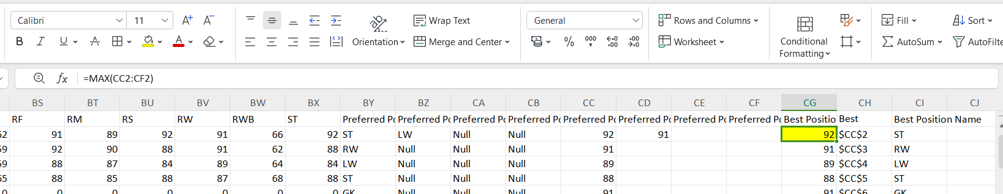

* **To find the Best Position cell address:**

=CELL("address",INDEX(CB2:CF2,MATCH(MAX(CB2:CF2),CB2:CF2,0)))

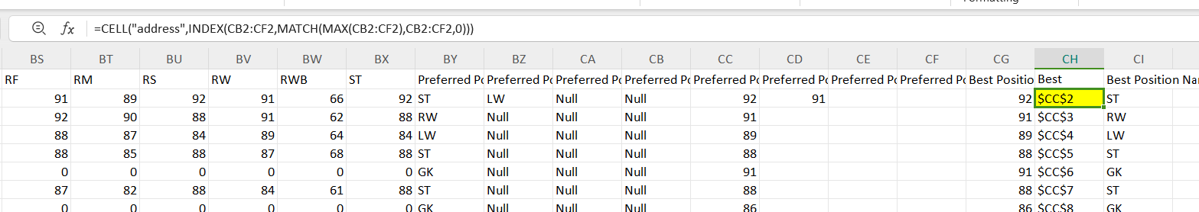

* **To find the Best Position Name from the maximum score obtained:**

=IFS(CG2=CC2,BY2,CG2=CD2,BZ2,CG2=CE2,CA2,CG2=CF2,CB2)

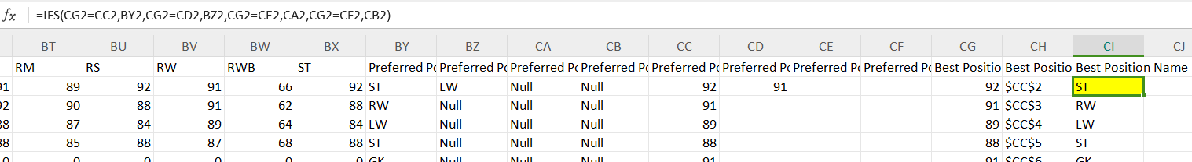

**To find the most common position in POWER BI,**

* + Created a new table with particular columns - using **UNION** function and **SELECTCOLUMNS** function from the original table/dataset
  + **COUNT ROWS** function used to count the number of occurrences of each position.

PreferredPositionsUnpivoted =

UNION(

    SELECTCOLUMNS(

        'Fifa Olympics dataset (2)',

        "Position", 'Fifa Olympics dataset (2)'[Preferred Position 1]

    ),

    SELECTCOLUMNS(

        'Fifa Olympics dataset (2)',

        "Position", 'Fifa Olympics dataset (2)'[Preferred Position 2]

    ),

    SELECTCOLUMNS(

        'Fifa Olympics dataset (2)',

        "Position", 'Fifa Olympics dataset (2)'[Preferred Position 3]

    ),

    SELECTCOLUMNS(

        'Fifa Olympics dataset (2)',

        "Position", 'Fifa Olympics dataset (2)'[Preferred Position 4]

    )

)

**COUNTROWS function:**

PositionCount = COUNTROWS('PreferredPositionsUnpivoted')